第10讲 SSB通信系统 10.20

表格1 SSB信号的时频域对比

Signal | Time-domain 时域 | Frequency-domain 频域
表达式
波形或频谱 | (绘制 SSB 时域波形) | （绘制 SSB 频谱）

表格2 抗噪声性能分析

Symbol | $${\text{P}}_{\text{si}}$$ | $${\text{P}}_{\text{ni}}$$ | $$\text{(}\text{SNR}{\text{)}}_{\text{i}}$$ | $${\text{P}}_{\text{so}}$$ | $${\text{P}}_{\text{no}}$$ | $$\text{(}\text{SNR}{\text{)}}_{\text{o}}$$ | $$G$$
Power
备注：

Discussion
Item | Content
Advantages | ①  ②  ③
Disadvantages | ②  ③

Example 3: Suppose the noise two-sided power spectral density of a channel is $P_{n}(f)=0.5×10^{−3}$ W/Hz. A SSB signal is transmitted on this channel. The power of the modulated SSB signal is 10 kW. The bandwidth of the message signal $m(t)$ is 5 kHz, and the carrier frequency is 100 kHz. An ideal band-pass filter is placed before the receiver. Try to find:
(1) the mid-band frequency of this ideal band-pass filter for the SSB signal;
(2) the input SNR of the demodulator ;
(3) the output SNR of the demodulator, and draw the output noise PSD of the SSB demodulator;
(4) the modulation system gain G of the SSB demodulator.

习题：In the analog FDM carrier telephone system shown in the figure, each voice signal occupies 4 kHz bandwidth and uses SSB modulation. A basic group contains 12 voice channels, with frequency range 60 kHz ~ 108 kHz. 5 basic groups form one supergroup.
- Calculate the total bandwidth of one basic group.
- What modulation type is adopted for each voice channel in this FDM telephone system? Explain why.
- A supergroup ranges from 312 kHz to 552 kHz. Find the total bandwidth of a supergroup. (4) Why do we adopt multi-stage modulation for FDM telephone instead of modulating all voice signals directly on one single carrier?

Proof Question证明题: Prove that the transfer function $\text{H}\text{(}\text{ω}\text{)}$ of the VSB filter satisfies:
$$\text{H}\text{(}\text{ω}\text{+}{\text{ω}}_{\text{c}}\text{)+}\text{H}\text{(}\text{ω}\text{−}{\text{ω}}_{\text{c}}\text{)=}\text{C}\text{, |}\text{ω}\text{|≤}{\text{ω}}_{\text{H}}$$
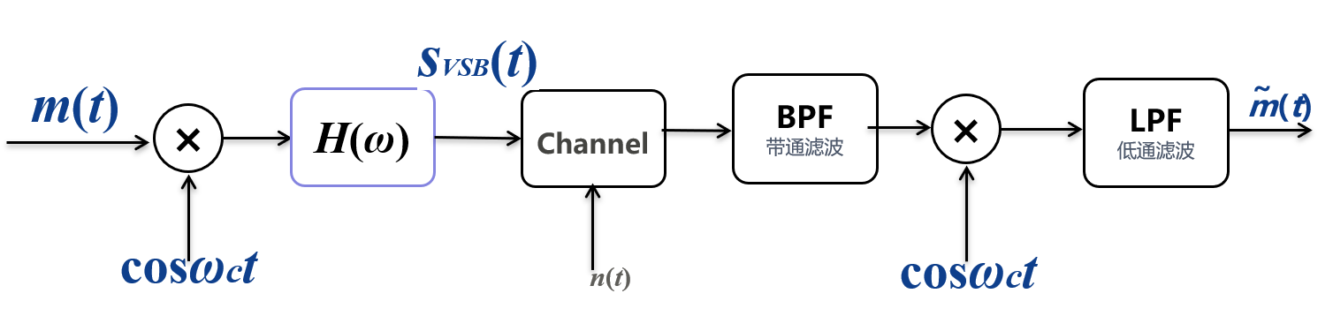
(提示：从 VSB 系统入手，依次分析信号频谱的变化；要求解调恢复的基带频谱相对原始基带无失真，将滤波器传输函数H(ω)视作未知量，推导求解约束条件。)

